

Elevator control

Group Number: 20

MICROPROCESSORS, PROGRAMMING AND INTERFACING (CS/EEE/ENI/ECE F241)

Group Number: **20**

*Design Question Number:* ***20***

Group Members:

|  |  |  |
| --- | --- | --- |
| **Sr. No.** | **Name** | **BITS ID** |
| **1** | Amrtanshu Bharadwaj | 2020B4AA1860G |
| **2** | Aman Suryavanshi | 2020B4A72016G |
| **3** | Arnav Gupta | 2020B4A71980G |
| **4** | Yashaswi Piplani | 2020B4A31845G |
| **5** | Aditya Halli | 2020B4A81851G |
| **6** | Bhavya Mehta | 2020B4AA1846G |

Contents

Acknowledgement 3

Design Specifications 4

System Specifications 5

Assumptions 7

Components 8

Address Mapping 9

• Memory Mapping 9

• I/O Mapping 9

Description Of I/O Devices 10

• 8253 10

• 8255 10

• 8259A 11

Flowchart 12

Datasheets 23

# Acknowledgement

We would like to thank Prof. K. R. Anupama and the entire teaching staff of the course Microprocessors, Programming and Interfacing (CS/EEE/ENI/ECE F241) for giving us this invaluable opportunity to enhance our understanding of the subject through the completion of this design project.

# Design Specifications

* The elevator operates along **4 floors**.
* When not in use, the elevator is always on the ground floor. The elevator can be called by pressing any one of **two buttons available on each floor**.
* One button is **up,** and the other is **down**.
* Whether the elevator stops at the floor or not depends on the lift's direction. For example, if the lift is moving upward and the person on the 2nd floor presses the down button, the lift will not stop in the current journey. When the lift reaches the 3rd floor and starts moving down, then the lift will stop on the 2nd floor.
* On **every floor, there is a 7-segment display** indicating the floor where the lift is right now. The display can be any value from 0 - 3. '0' indicates the ground floor.
* Inside the lift - **buttons are available for floor selection**.
* **The floor towards which the lift is moving is also displayed** within the lift.
* **Doors to the lift open and close automatically.**
* When the lift reaches any floor where it has to stop, it opens automatically and closes when a button called "Door Close" is pressed. **The lift does not move until the door is closed.**
* The system runs from a standard power inlet.

# System Specifications

* An electromagnetic system is used to open and close the door. You need to provide the on/off control. A heavy-duty servo motor is used for lift movement. You need to provide the input to the driver circuit.
* The inputs are direction (up/down) and a PWM input, which controls the lift's speed. The duty cycle can vary from 20% to 50%.
* The frequency of the PWM signal is 10 Hz.
* For detecting whether the lift has reached a floor, the system has a set of three sensors – two 'coarse' sensors and a 'fine' sensor. All the sensors are contact switches; when the lift reaches the point where the sensors are placed, the contact switch gets pushed in. The output of contact switches is low when closed and high otherwise. The sensor arrangement is represented in the fig below:

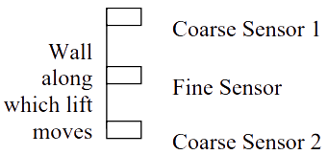

* Only Coarse Sensor 1 and Fine Sensor will be available on the ground floor. On the 3rd floor, only Coarse Sensor 2 and the Fine Sensor will be available.
* The lift starts at the ground floor at a low speed, gradually accelerating to the maximum speed. It should operate at maximum speed when it reaches 'Coarse Sensor 1". As the lift moves up, if it has to stop at floor '1', when Coarse Sensor 2 is detected at that floor, the lift starts moving at a low speed until it can stop when it reaches the Fine sensor. When it starts again, it moves at low speeds and reaches the maximum possible speed when it reaches the Coarse sensor 2. The same is done in the reverse direction with the appropriate sensors.
* The speed at which the lift moves is proportional to the duty cycle. The duty cycle must gradually increase from 20% to 50% for acceleration. And for deceleration, the duty cycle was reduced from 50% to 20%. The increase is in steps of 10%.

# Assumptions

* Two different sensors cannot be simultaneously ON.
* The direction bit flag is directly given to the motor circuit.
* Lift buttons have a debounce delay of 5ms since they are modelled as push buttons.
* 20% duty cycle is a complete stop, and the 50% duty cycle is the maximum speed the lift can reach.
* The door closes as soon as the close door button is pressed or closes automatically after 10s of no activity.
* The fine sensor remains pressed when the lift remains stationary on a floor, and an interrupt is raised only once during that time.

# Components

|  |  |  |
| --- | --- | --- |
| **Device Name** | **Count Used** | **Description** |
| 8086 | 1 | 16-Bit Intel Microprocessor |
| 8284 | 1 | Used to generate clock for 8086 and 8253 |
| 8253 | 1 | Programmable Interval Timers |
| 8255 | 1 | General Purpose Programmable I/O Device |
| 8259A | 1 | To give priority to Interrupts |
| 6116 | 4 | 2K Programmable RAM chips |
| 2716 | 2 | 2K Programmable ROM chips |
| 7408 | 2 | Quad 2 I/P AND Gates |
| 7432 | 2 | Quad 2 I/P OR Gates |
| 7404 | 1 | Hex 1 I/P NOT Gates |
| 7-Segment Display | 5 | Display which shows numerical values |
| 7447 | 1 | BCD to 7-Segment Decoder |
| Push Buttons | 11 | Lift and Floor buttons |
| Contact Switches | 10 | Fine, Coarse 1 and Coarse 2 sensors |
| TIP120 | 2 | Darlington transistor to amplify current |
| TB67H451FNG | 1 | H-Bridge functioning as a motor driver |
| 74LS373 | 3 | Octal Latch |
| 74LS245 | 2 | Octal Bus Transceiver |
| 74LS138 | 2 | 3x8 Decoder |
| 74LS244 | 1 | Octal Tri-state Buffer |
| Pull-up resistors |  | Ensures reliable voltage level for a floating signal |

# Address Mapping

### Memory Mapping

|  |  |  |
| --- | --- | --- |
| **Device** | **Initial Address** | **Final Address** |
| ROM1 | 00000h | 00FFFh |
| RAM | 04000h | 04FFFh |
| ROM2 | FF000h | FFFFFh |

### I/O Mapping

|  |  |  |
| --- | --- | --- |
| **Device** | **Initial Address** | **Final Address** |
| 8253 | A0h | A6h |
| 8255 | B0h | B6h |
| 8259A | C0h | C2h |

# Description Of I/O Devices

### 8253

The 8253 chip is utilized to generate the PWM signal that controls the lift's speed and downscale the frequency.

Address and configuration of counters:

|  |  |  |  |  |  |
| --- | --- | --- | --- | --- | --- |
| **Counter Number** | **Address** | **Mode of Operation** | **Counter Stored** | **Control Word** | **Output** |
| Counter 0 | A0h | Mode 3 | 25000d | 36h | 100Hz |
| Counter 1 | A2h | Mode 3 | 10d | 56h | 10Hz |
| Counter 2 | A4h | Mode 1 | 8d (20% PWM)  7d (30% PWM)  6d (40% PWM)  5d (50% PWM) | 92h | 10Hz |
| Control Register | A6h | - | - | - | - |

### 8255

8255 is used to interface the lift buttons, 7-segment displays, and Door Close mechanism via the electromagnetic system and provide the lift direction to the motor driver via the Darlington Transistors and H-Bridge.

|  |  |  |
| --- | --- | --- |
| **Port** | **Address** | **Specification** |
| Port A | B0h | 7-segment Displays |
| Port B | B2h | Lift Buttons |
| Port C | B4h | Lift Buttons, lift direction to motor driver and door close to lifting door. |
| Control Register | B6h | - |

### 8259A

8259A is used to prioritize the interrupts generated in the design throughout the working of the lift. Interrupts generated by the lift buttons are connected to IR0, interrupts generated by any Fine Sensor are connected to IR1, interrupts generated by Coarse Sensor 1 on any floor are connected to IR2 and interrupts generated by Coarse Sensor 2 on any floor are connected to IR3.

Addressing of 8259A:

Memory locations C0h and C2h are used as the addresses of 8259A.

# Flowchart

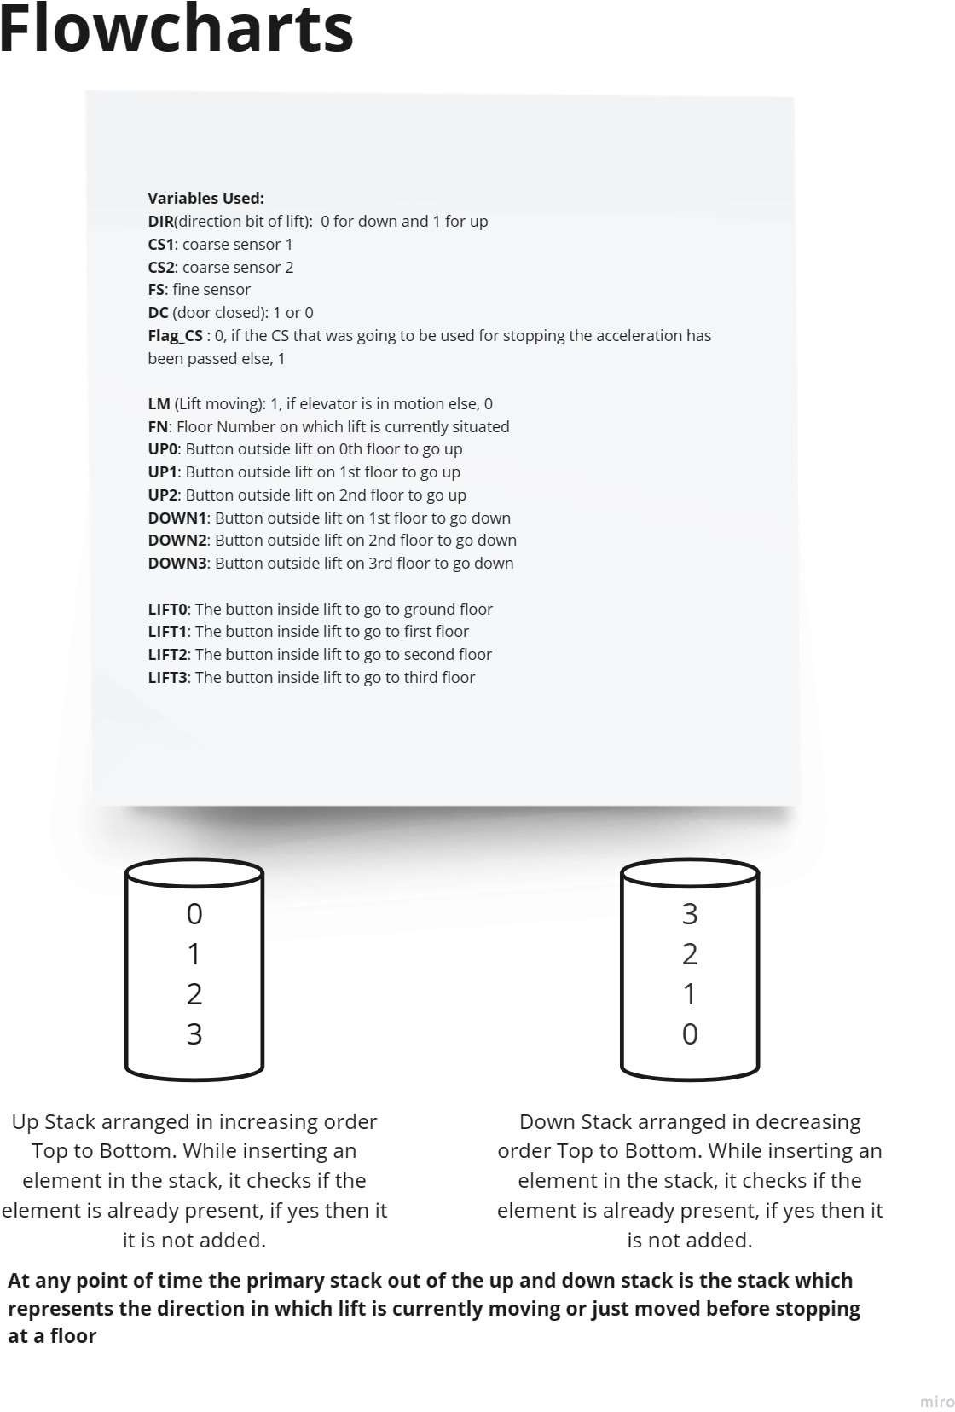

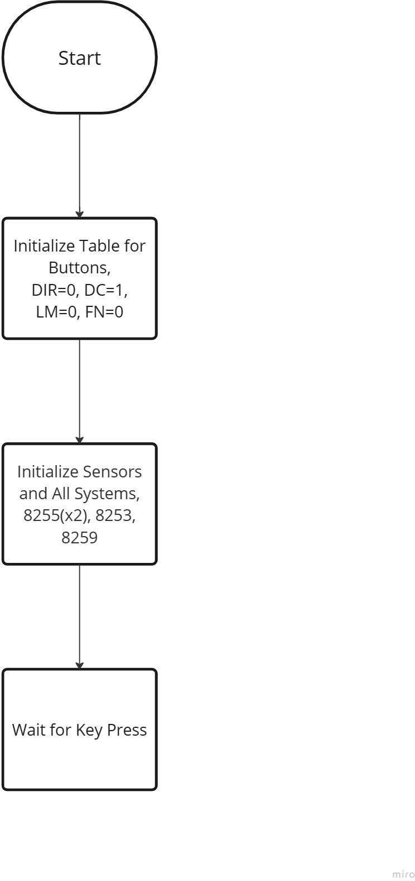

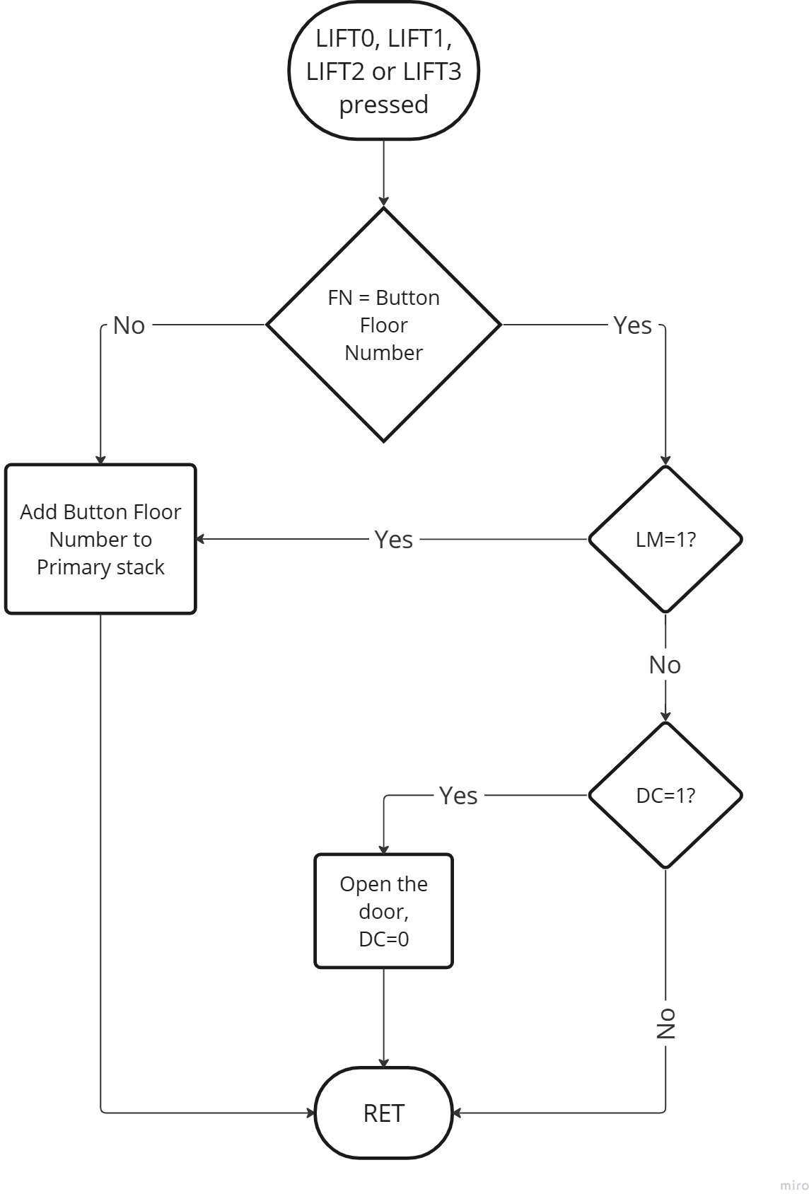

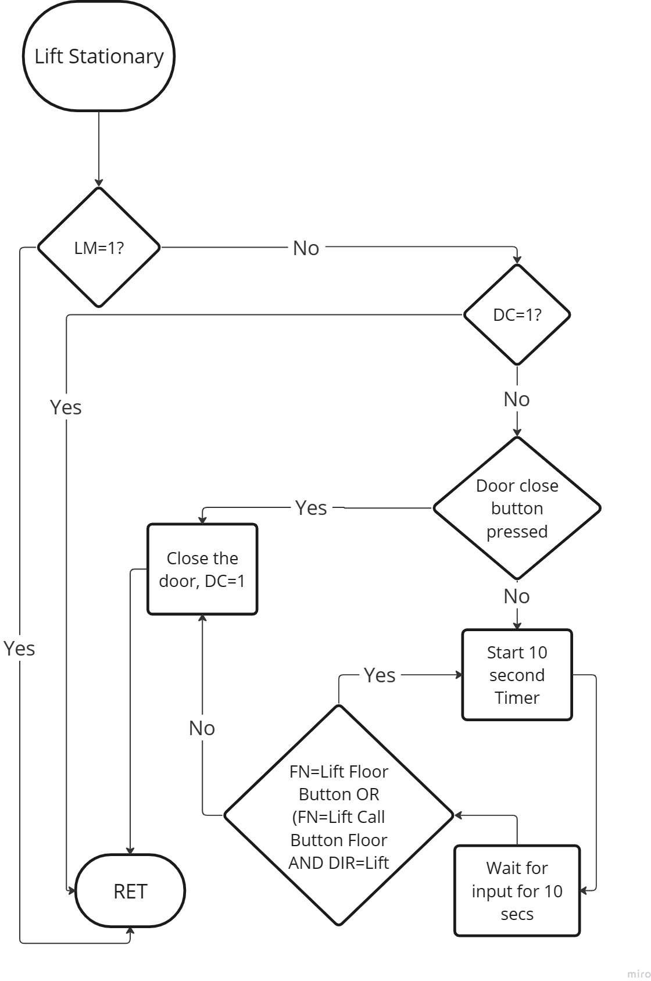

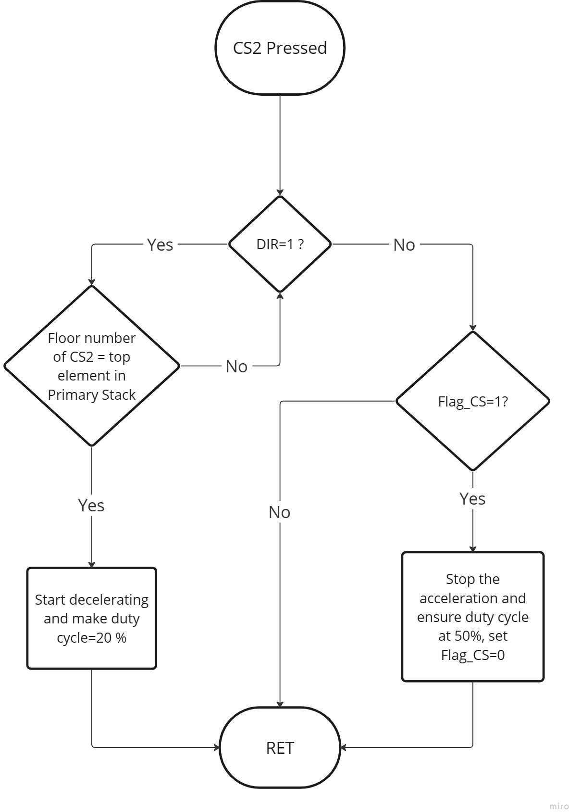

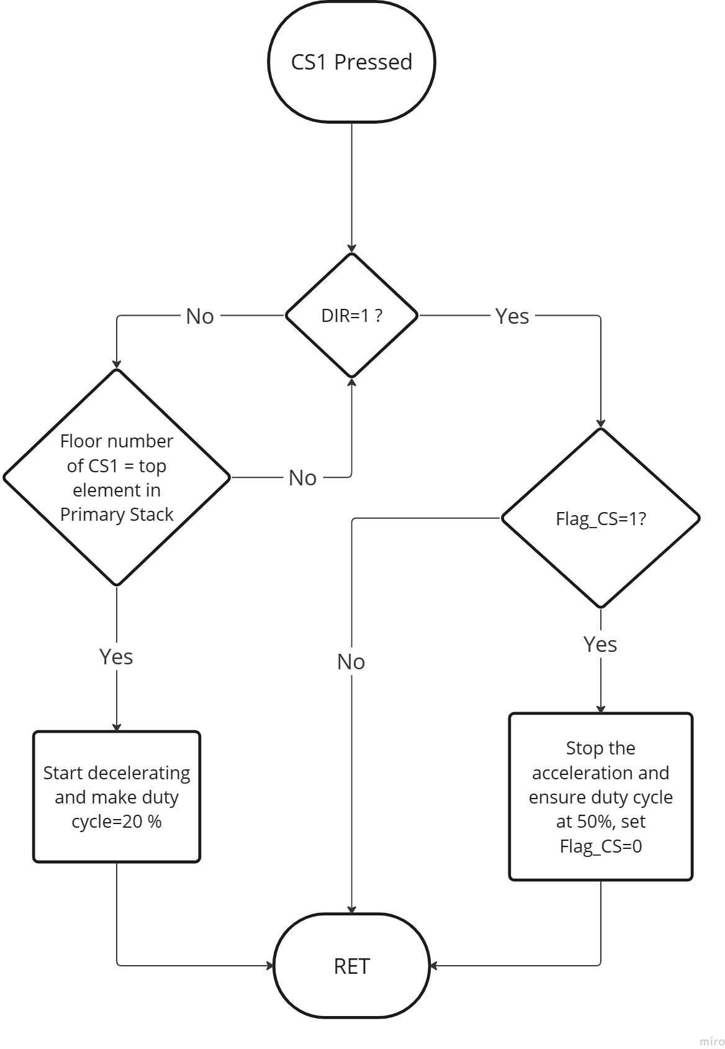

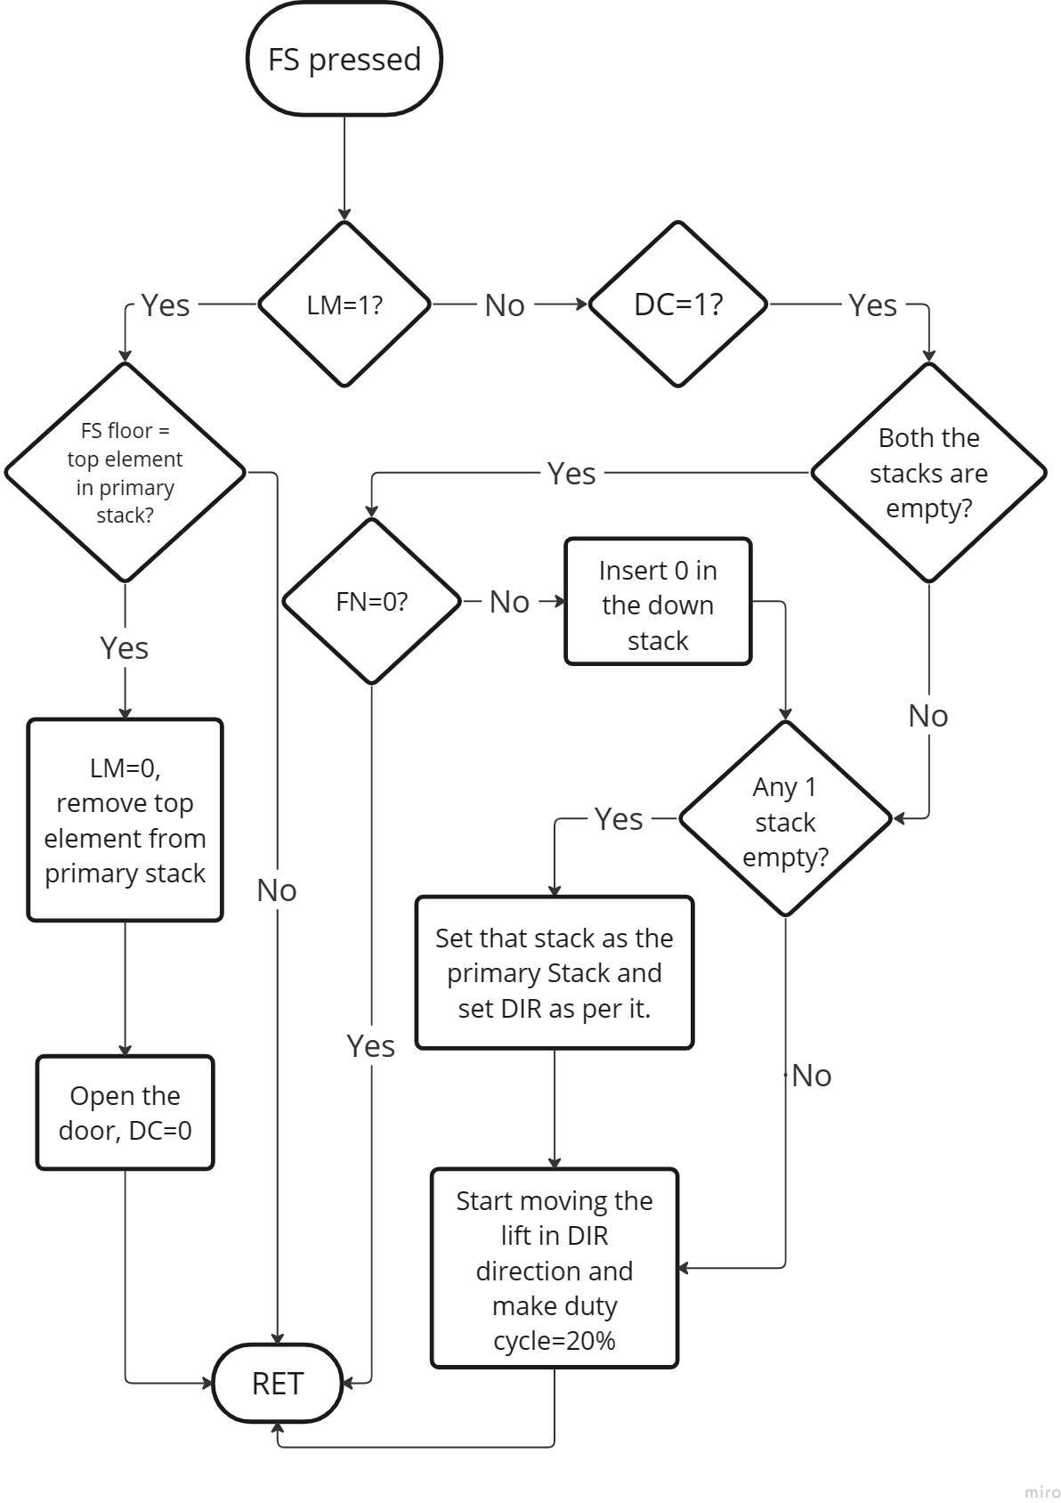

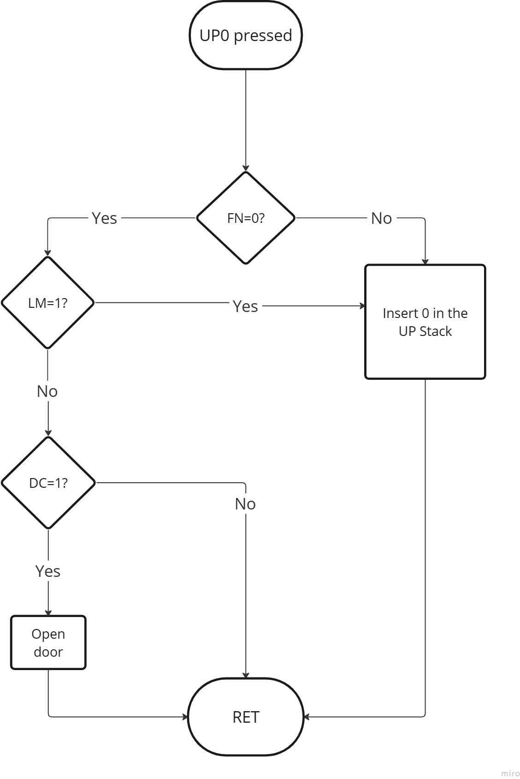

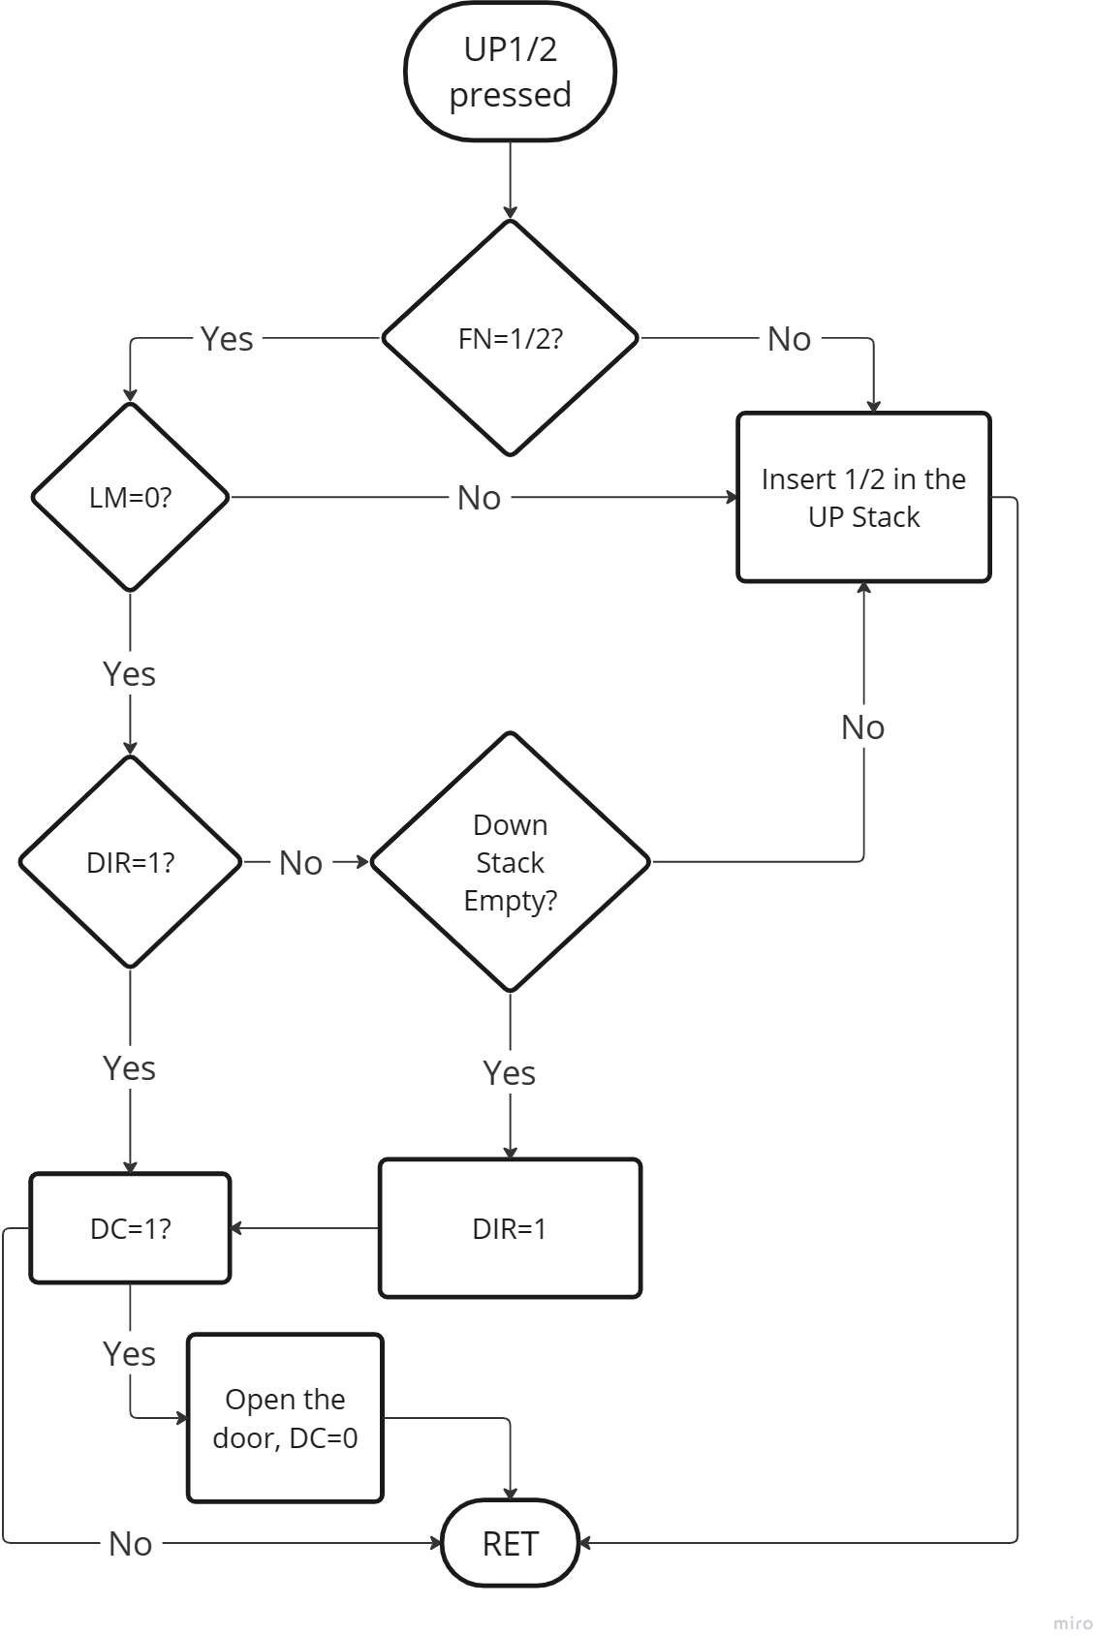

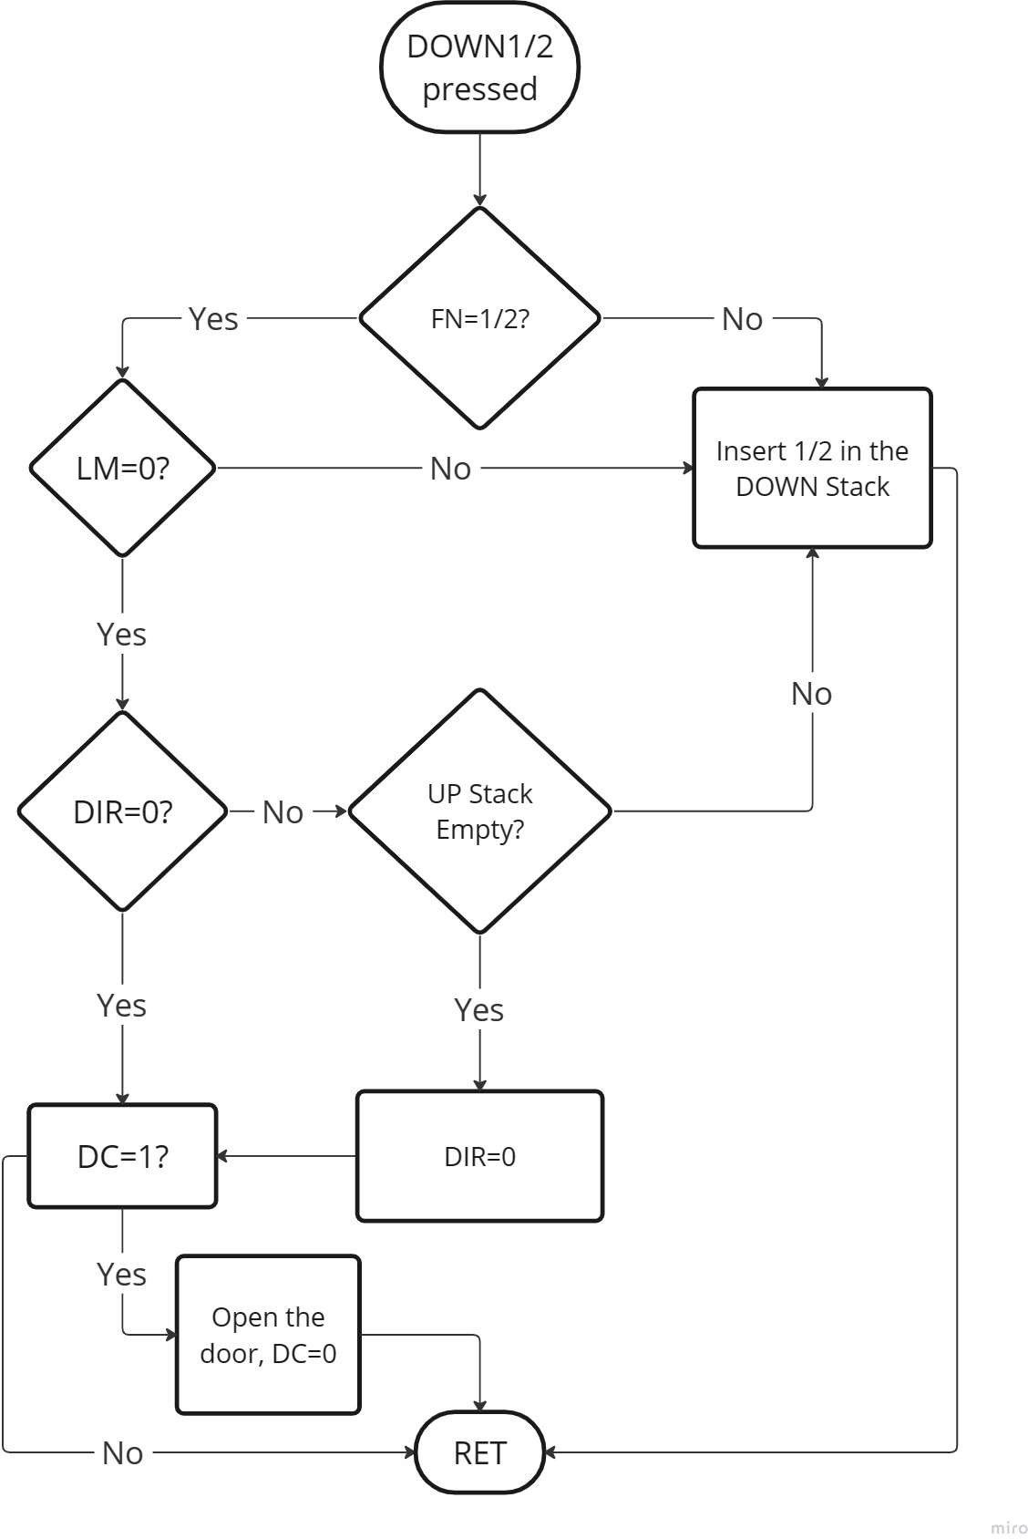

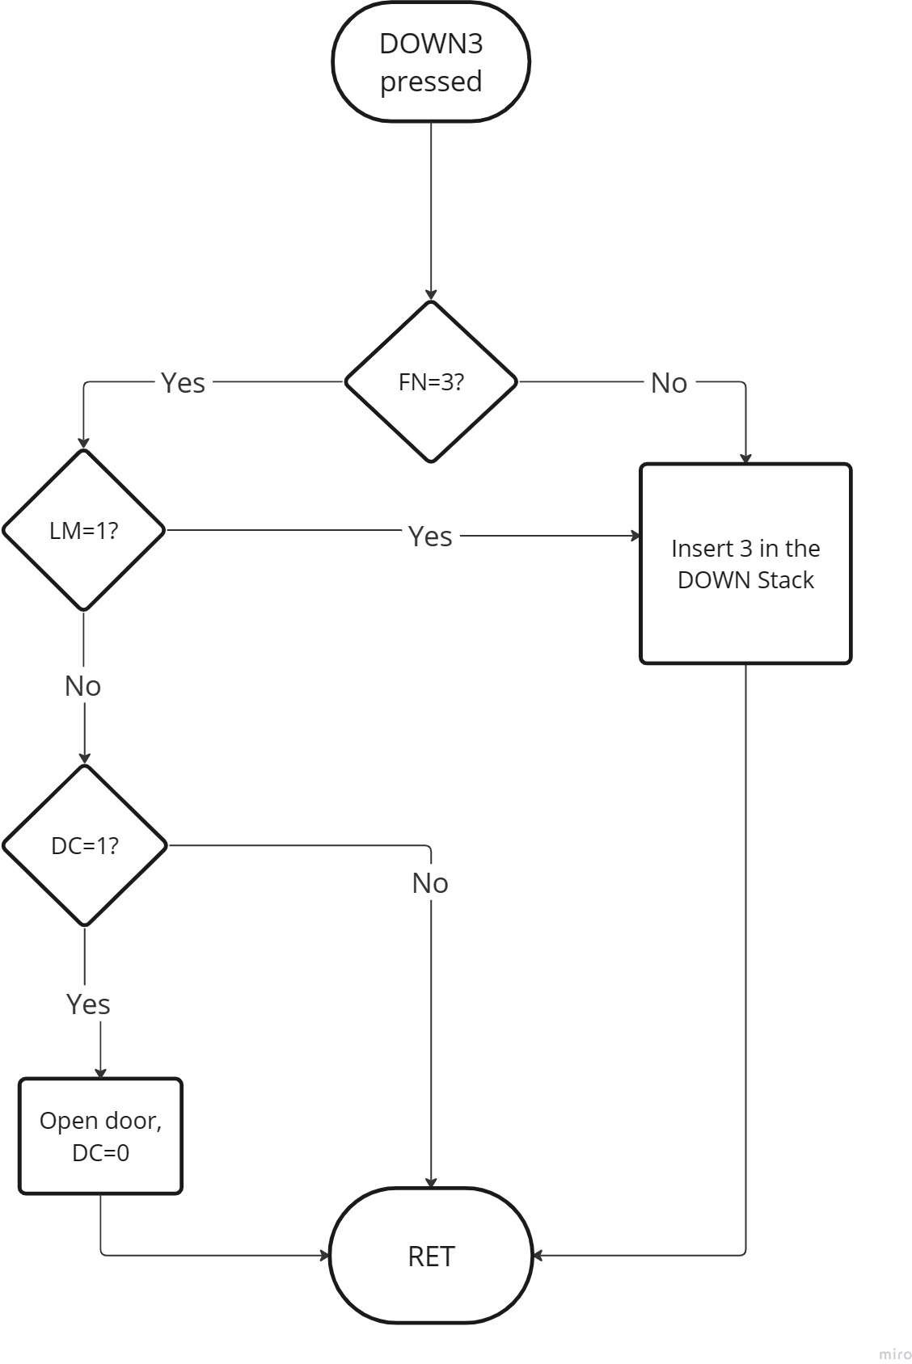

# Datasheets

P.T.O to the next page